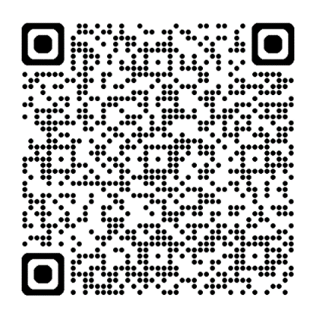



**Sixth Annual**

**Multidisciplinary Trauma Symposium**

**“From Scene to Discharge and Beyond: Trauma Care Made in Michigan”**



**DATE:**

**Tuesday, September 17th, 2024**

**TIME:**

**8:00**

**AM - 4:30 PM-EST**

**LOCATION:**

**Trinity Health Oakland**

**Franco Education Center**

**44405**

**Woodward Ave. Pontiac, MI**

**48341**

**KEYNOTE PRESENTER**

**Dr. Benjamin Mosher MD, FACS**

**Navigating a Multiple Casualty Incident: Lessons Learned from the Michigan State University Shooting.**

**Sparrow Hospital**

Trauma Medical Director

General Surgery and Surgical Critical Care.

**REGISTRATION:**

**:**

* Trinity Health Affiliates and EMS = FREE
* Non-Affiliates = $50
* Lunch included.
* Scan the QR to register today!

**Registration Open**

**Purpose:**

This event will focus on patient-centered care from scene of the injury, through acute treatment, and on to physical and mental rehabilitation. The goal of the education is to optimize the patients return to the highest level of function through evidence-based care of a patient-centered multidisciplinary team.

**Objectives:**



Participants will learn about the resources necessary to successfully manage a mass casualty incident.



Participants will have the opportunity to review and discuss both

adult and pediatric injuries, diagnostic

imaging,

and treatment

interventions.



Participants will understand the history of trauma, how traumatic events can affect our mental health, and the actions providers can take to provide trauma-informed care.

**Intended Audience:**

**Nurses, Pharmacists, Physicians, Social Workers, Advanced Practice Providers, Psychologists, EMS and Fire professionals.**

**All who have an active involvement in Trinity Health’s Trauma System are invited.**

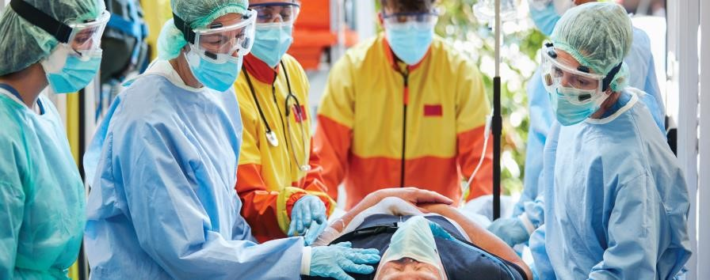

**QUESTIONS**

**?**

Anita.Barksdale@trinity

-

health.org